Edits required in the protocol published on 18-2-2020.

1. Results were reanalysed by a biostatistician and the results section has been edited as per the results copied below.

COMPDIAM PARTICIPANT FLOW

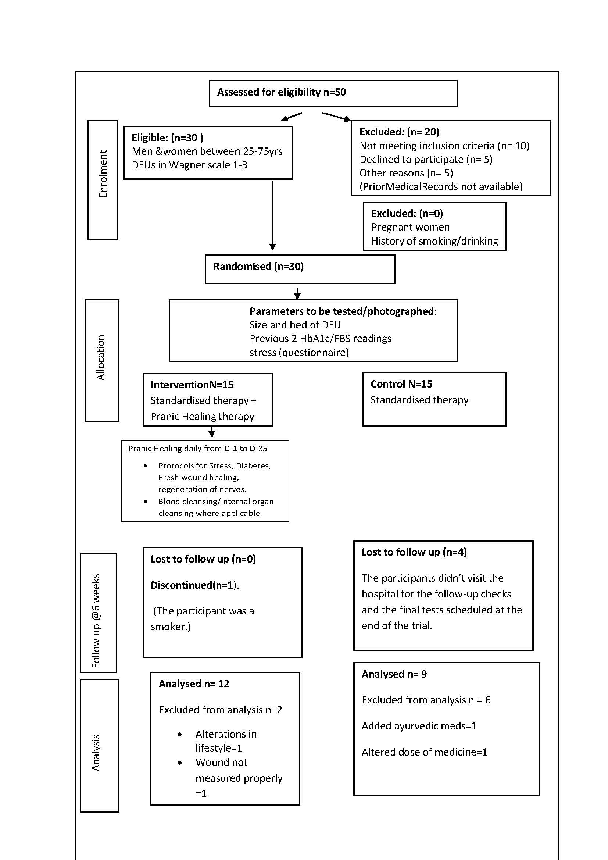

Demographic characteristics and distribution at baseline

No of participants enrolled in Control & Intervention groups
Table :1
N=30 |  | Count | Column N %
group | Control(SOC) | 15 | 50.0%
 | Intervention(Pranichealing+SOC) | 15 | 50.0%

Table 2: Gender distribution of patients studied

Gender | Group I | Group II | Total
Female | 3(20%) | 2(13.3%) | 5(16.7%)
Male | 12(80%) | 13(86.7%) | 25(83.3%)
Total | 15(100%) | 15(100%) | 30(100%)
P=1.000, Fisher Exact test

Table 2: Age distribution of patients studied

Age in years | Group I | Group II | Total
41-50 | 6(40%) | 1(6.7%) | 7(23.3%)
51-60 | 5(33.3%) | 5(33.3%) | 10(33.3%)
61-70 | 4(26.7%) | 7(46.7%) | 11(36.7%)
>70 | 0(0%) | 2(13.3%) | 2(6.7%)
Total | 15(100%) | 15(100%) | 30(100%)
Mean ± SD | 53.03±10.39 | 62.00±8.48 | 57.53±10.37
P=0.015, student t test

Table 3 : Grade of Wagner Scale Diabetic Foot Ulcer on recruitment
Wagner grade  on recruitment |  | group
 |  | Control(SOC) |  | Intervention (Pranic healing+SOC)
 |  | Count | Column N % | Count | Column N %
 | Grade 1 | 9 | 60 | 5 | 33.33
 | Grade 2 | 6 | 40 | 7 | 46.66
 | Grade 3 | 0 | 0% | 3 | 20.00

Table 2 : Results
Summary of Primary Outcome Measures at the end of the trial

A. Statistical Interpretation
Table: Intra group Comparison (Between D1 and D35) of wound size among test group and control group –Paired T test

 |  | N | Mean | SD | Mean Difference | t | P Value | 95% Confidence Interval of the Difference
 |  |  |  |  |  |  |  | Lower | Upper
Test Group | D1 | 12 | 4.25 | 5.01 | 2.15 | 2.916 | 0.014 | 0.52 | 3.76
 | D35 | 12 | 2.10 | 2.7
Control Group | D1 | 9 | 10.16 | 25.07 | -1.84 | -0.807 | 0.443 | -7.09 | 3.41
 | D35 | 9 | 12.0 | 31.78
*Statistical significance set at 0.05; N: Number of samples; SD: Standard Deviation
Interpretation:
Paired sample t test displays a statistically significant reduction in wound size(t=2.91; P=0.014; CI: 0.52 to 3.76) after intervention with Pranic Healing (Test Group) for 35 days (D35) when compared to D1. The control group did not exhibit a statistically significant difference in wound size between D1 and D35. (t=-0.807; P=0.443; CI: -7.09 to 3.41).

Table: Intra group Comparison (Between D1 and D35) of HBA1c among test group and control group –Paired T test

 |  | N | Mean | SD | Mean Difference | t | P Value | 95% Confidence Interval of the Difference
 |  |  |  |  |  |  |  | Lower | Upper
Test Group | D1 | 11 | 9.86 | 2.31 | 1.45 | 2.811 | 0.018* | 0.301 | 2.607
 | D35 | 11 | 8.40 | 2.08
Control Group | D1 | 8 | 8.78 | 1.48 | 0.33 | 1.093 | 0.311 | -0.392 | 1.067
 | D35 | 8 | 8.45 | 1.67

Interpretation:
Paired sample t test displays a statistically significant reduction in HBA1c level (t=2.81; P=0.018; CI: 0.301 to 2.607) after intervention with Pranic Healing (Test Group)for 35 days (D35) when compared to D1. The control group did not exhibit a statistically significant difference in HBA1c levels between D1 and D35. (t=0.33; P=0.311; CI: -0.392 to 1.067).

B. Outcomes represented by change in percentages
Average change across groups in primary outcome during the trial
S No | Parameter | Group average
 |  | Trial  (N=12) | Control  (N=9)
1. | Reduction in wound size (cm²)  (Mean; ± SD)  (D35-D1) | 2.15 ±2.7  (CI: 0.52 to 3.76)  P=0.014* | -1.84±31.78  (CI: -7.09 to 3.41)  P=0.443
2 | Percentage change in wound size  (D1-D-35) | 69.07 % | 23.22%
3. | Improvement in wound bed (approx) (qualitative) | 52.50% | 29.4%
4. | Reduction in Wagner Grade (moved to lower grade) (number) | 66.67%  8/12 | 44.44%  4/9
5. | Improvement in Monofilament test  (number) | 18%  2/11 | 0%
6. | Improvement in Vibratory Perception Test (number) | 45%  5/11 | 22.3%  2/9
7. | Reduction in stress/anxiety  (number) | 75%  9/12 | 11%  1/9
8. | Lowering of Hba1c level  (Mean; ± SD)  (D35-D1) | 1.45 ± 2.08  CI: 0.301 to 2.607  P=0.018* | 0.33 ±1.67  CI: -0.392to 1.067  P=0.311
9. | Percentage lowering of Hba1c level  (D35-D1) | 13.47% | 3.43%

Average change across groups in secondary outcome during the trial

S No | Parameter | Group average
 |  | Trial | Control
1. | Lowering of average glycemic level (hba1c/RBS) | 14.24% | 4.8%

Adverse Events: There were no adverse events associated with this trial.

